Name – SUMIT HARISHARAN SINGH
Computer Network Lab
Date: 27.8.2026
Host Commands
- D:\hostname

- D:/ipconfig -all
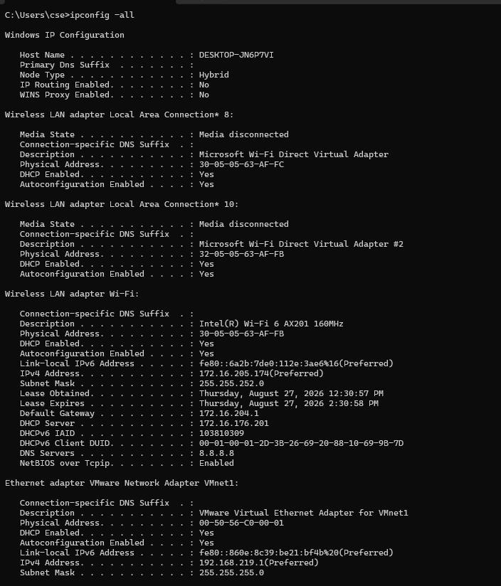
- D:/getmac
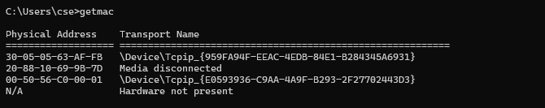
- D:/nslookup google.com
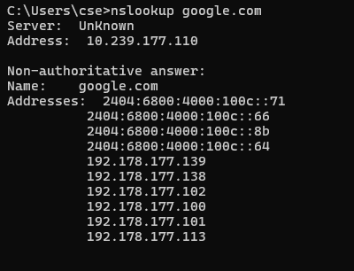

- D:/nslookup 8.8.8.8
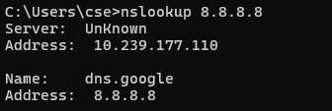
- D:/ipconfig /displaydns
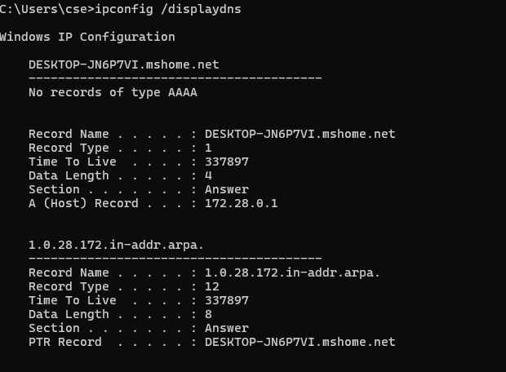

- D:/Ping google.com
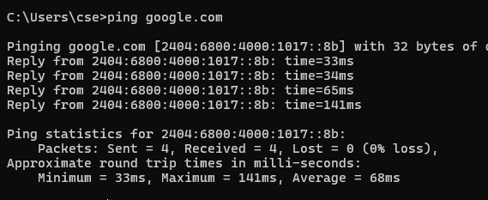

- D:/ipconfig /flushdns
